Autoclave Operating Instructions

Beginning in 2019, new personnel must receive hands-on, in person training before using any autoclaves in Nash Hall.

ASK for instructions if you are unclear or have forgotten how to operate the autoclave. Each lab should identify one person that is familiar with operating the autoclaves on your floor. Cindy Fisher, fisherc@ oregonstate.edu or Val Elias, valerie.elias@oregonstate.edu are the departmental liaisons for training and troubleshooting issues with autoclaves in Nash.

Sign In: Each autoclave has a separate clipboard for sign in purposes.

Date | START Time | RUN Time | Chamber Pressure | Condition of Autoclave | Lab Name & Department if not in Microbiology | User Name, First &Last

NOTE: All items that are autoclaved MUST be placed in secondary containment containers.

- Metal pans are the preferred secondary containment containers because of the rapid heat transfer to the items being sterilized.
- Polypropylene (#5) can resist autoclave temperatures.
- Polycarbonate (#7) can also withstand high temperatures.

Non Autoclaveable Plastics
- Polystyrene (PS #6)
- Polyvinyl chloride (PVC #3)
- Nylon, acrylic, low-density polyethylene (LDPE, #4)
- High-density polyethylene (HDPE #2)

NEVER AUTOCLAVE THE FOLLOWING:
- Flammable, reactive, corrosive, toxic or radioactive materials
- Household bleach- explosive hazard
- Sharps- Contact EHS for pickup
1. Check the strainer to see if it is clogged before items are put in the autoclave. The strainer is located on the bottom of the chamber near the door and must be unscrewed to remove the strainer. The autoclave timer will not start the timing cycle if the strainer is clogged.

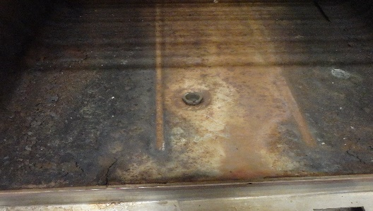

2. Place containers in the autoclave.

3. Close the door. Rotate the handle clockwise until it is snugly closed.

4. Open the glass-faced door in the upper right corner. Set STERILIZE time and, if needed, set DRY time. Note: Never use a fast exhaust or fast exhaust & dry cycle when autoclaving liquids

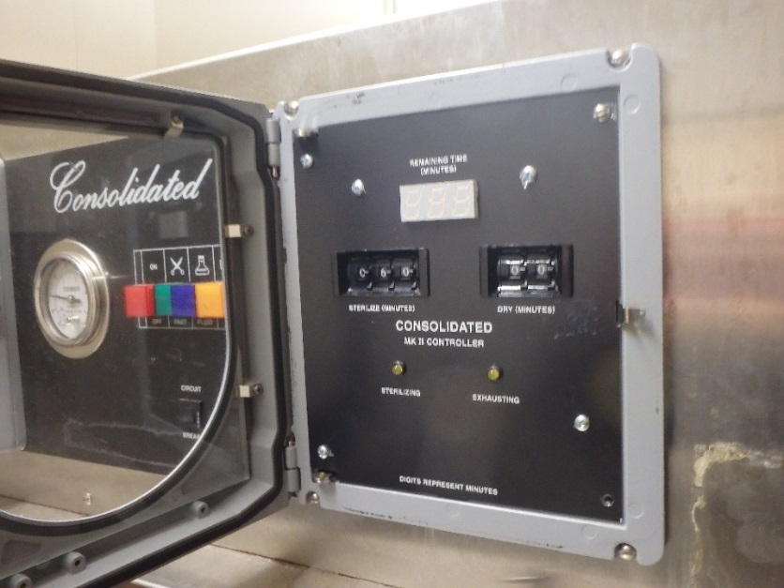

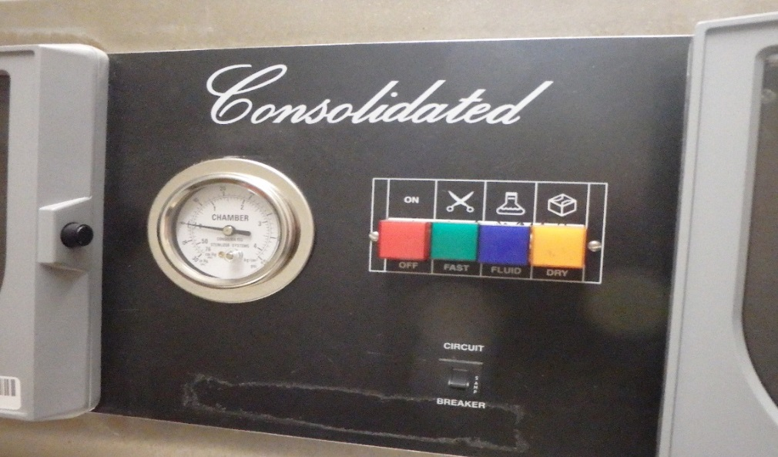

5. Select the SETTING you want by pushing in the button that corresponds to:

ON-OFF | FAST EXHAUST | FLUIDS | DRY

Note: the push button covers may be a different color than what is displayed in this instructional document. The order of the button function is correct and does not change.

EXPLANATION OF AUTOCLAVE CYCLES

FAST EXHAUST- Pressure will decrease rapidly at the end of sterilization. Never use the Fast Exhaust cycle for any type of liquid or agar

FLUIDS – Pressure decreases more slowly at the end of sterilization. Make sure that the dry cycle timer is set on zero.

DRY – Use this setting for paper goods, cotton swabs, etc. This is a fast exhaust cycle that has a dry vacuum cycle at the end. The dry timer must be set in order for the vacuum cycle to work.
Never use the fast or dry cycle for any type of liquid or agar

6. Push in the RED button to turn the autoclave on.

7. Wait until the temperature reaches 121° C and the RED sterilization light in the glass-faced box turns on before recording the Chamber Pressure

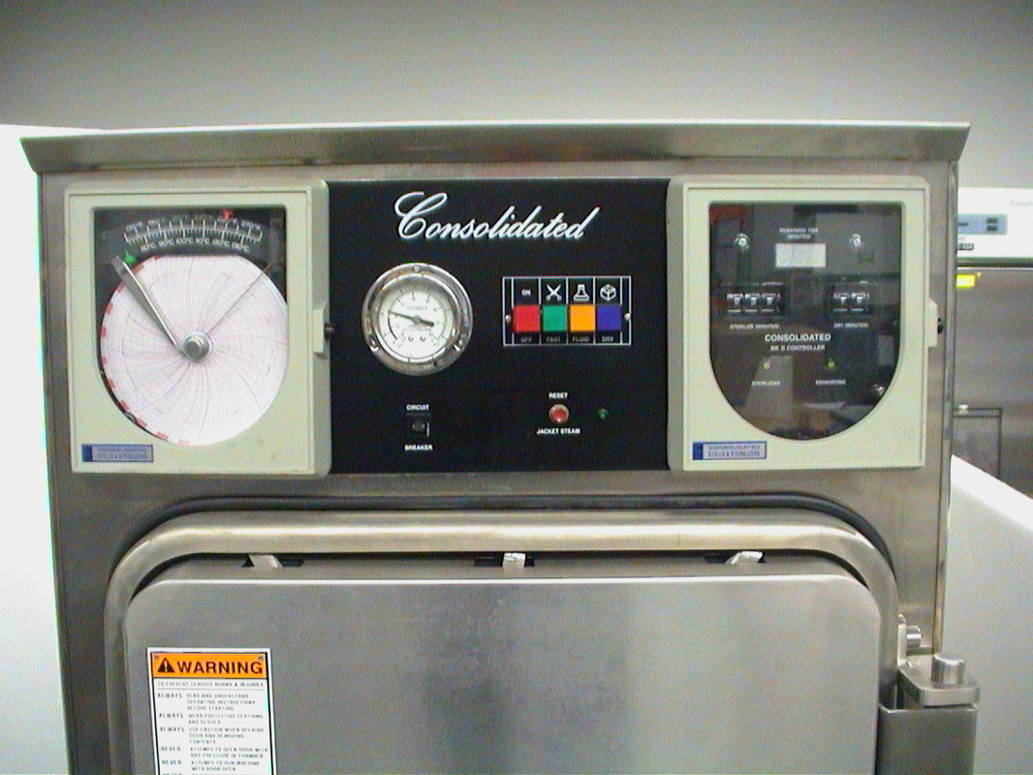

8. Record the chamber pressure on the sign in log. The chamber pressure should be 16-20 psi once the sterilization cycle starts. Anything below 16 psi should be reported.
Email fisherc@oregonstate.edu

9. At the end of the run, insure the CHAMBER PRESSURE has returned to ZERO before attempting to open the door. The FLUIDS cycle takes much longer than FAST EXHAUST – be patient. If the door cannot be easily opened, WAIT 10 minutes before trying again.

10. To open the door: Turn off the autoclave by pushing the RED off button before opening the door. Rotate the handle counterclockwise. Step to the side and crack open the door. Allow the steam to escape from the chamber, open the door and remove your items.

11. As a courtesy to others needing to use the autoclave, promptly remove your items when the cycle is completed and you can easily open the door. Wear protective, heat resistant gloves when removing items.

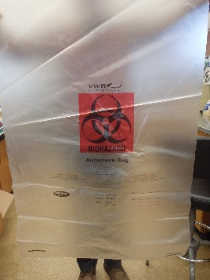

Autoclave bags must put into black trash bags before disposing of in the dumpster.

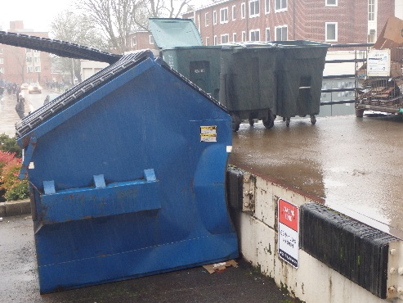
NOTE: Autoclaved waste materials should be taken directly to the dumpster at the loading dock for disposal.

PROBLEM SOLVING

- The timer won’t start timing even though the jacket pressure, chamber pressure and temperature are at the normal settings.
Likely cause: The timer will not start when the strainer in the bottom of the autoclave is clogged.

Solution: Abort the cycle by pushing the Red on/off button to off. The steam will slowly evacuate the chamber so the door can be opened and the strainer can be cleaned out.

- There is a high pitched squeal coming from the autoclave and there is steam coming out from around the door. The handle doesn’t move any more so it must be tightened enough.
Likely cause: The door was not tightened enough before starting the sterilization cycle. The steam pressure in the chamber prevents the handle from rotating once the cycle has started.

Solution: Abort the cycle by pushing the Red on/off button to off. If possible, turn off the steam to the autoclave. The steam will slowly evacuate the chamber so the door handle can be tightened more securely. Restart the cycle again.

- My flask of agar broke in the autoclave and I didn’t have it in a secondary container. There is agar in the bottom of the autoclave and it is running into the drain.

Solution: Remove as much of the liquid agar as possible with paper towels. Then pour large quantities of hot water in the bottom of the autoclave to flush the drains of any remaining agar to prevent the agar from solidifying in the drain lines.

Prevention: Always use secondary containment vessels whenever any type of liquid or discards are autoclaved. Make sure that the autoclave cycle is set for fluids/liquids by pushing the Yellow button and the dry cycle timer is set to zero.

